The Release Tab under O-U-1 has two delivery dates for each item.

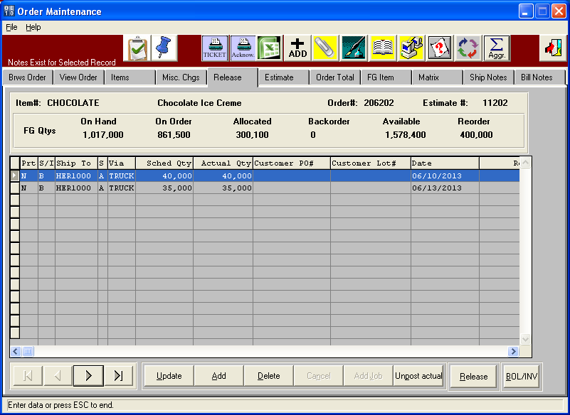

Release Button with Toggle Boxes Unchecked will combine all Items to new Release by Date.

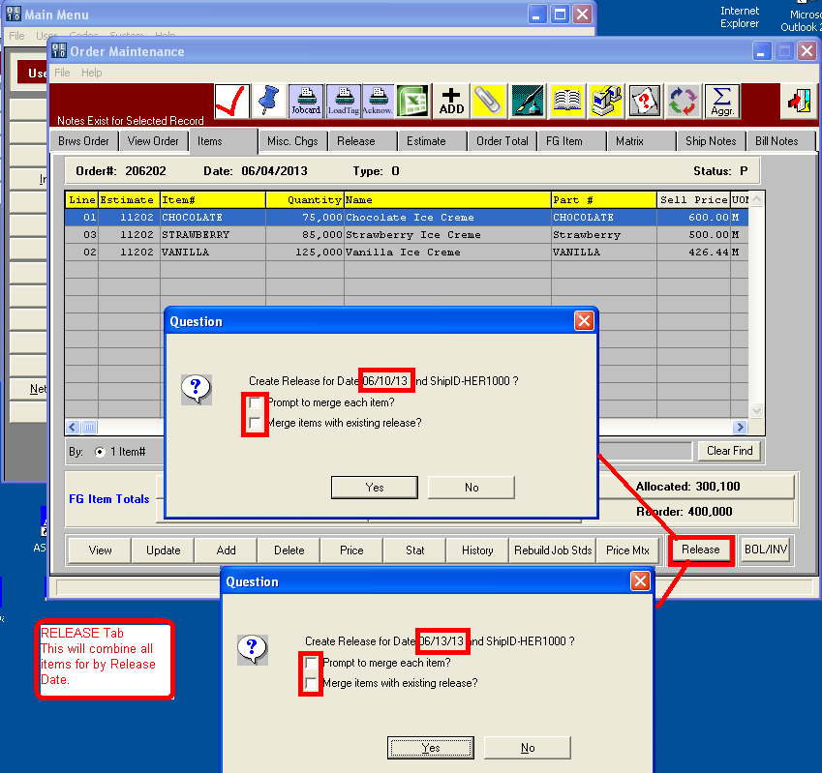

Multiple Releases are Created

